|

**Polling District and Polling Place Review 2025**

**Blakelaw and Cowgate Ward**

**Parliamentary Constituency:** Central and West

**(Proposed) Polling Districts:** C01, C02, C03, C04

The Local Government Boundary Commission for England are an independent body accountable to Parliament.  They are responsible for reviewing councils to make sure their patterns of internal wards are fair and sensible.   Their reviews include at least two rounds of public consultation before they make recommendations for change.

The final recommendations were published on 7 January 2025, and the new arrangements apply to local elections from 2026.

As a result of changes to ward boundaries the Acting Returning Officer (ARO) is conducting a review of polling districts and polling places to ensure that they are suitable for the new ward boundaries.

For more information on the local government boundary review visit:  <https://www.lgbce.org.uk/all-reviews/newcastle-upon-tyne>

This document provides details of the review, along with the initial recommendations and comments of the Acting Returning Officer (ARO). Also, the election rules require the ARO to decide how many polling stations are required for each polling station and the ARO must allocate electors to the polling stations in such manner as they think most convenient.

These recommendations will be open to all residents, stakeholders, and any interested parties. We shall be seeking representations from local disability groups on the accessibility and suitability of polling places. Any comments should be addressed in the first instance to pollingplaces@newcastle.gov.uk where they will be collated on behalf of the (Acting) Returning Officer.

We considered the following factors:

* **Identifying new polling places:** We will look for new polling places in areas where the existing provision is unsuitable or unavailable.
* **Feedback:** We will consider feedback received following recent elections, consultation from members of the public, elected members, and other stakeholders.
* **Accessibility:** We will try to ensure that every polling place is accessible to electors with disabilities.
* **Facilities**: We will make sure that all electors have such reasonable facilities for voting as are practicable in the circumstances.
* **Elector numbers:** We will try to comply with the Electoral Commission guidance on the maximum number of electors that should be allocated to a polling station which should not exceed 2,250.
* **Future housing developments**: We will consider the impact of proposed housing developments on polling station electorates.

**(Current) Blakelaw Ward**

This map shows the current ward and polling district boundaries and the polling places.

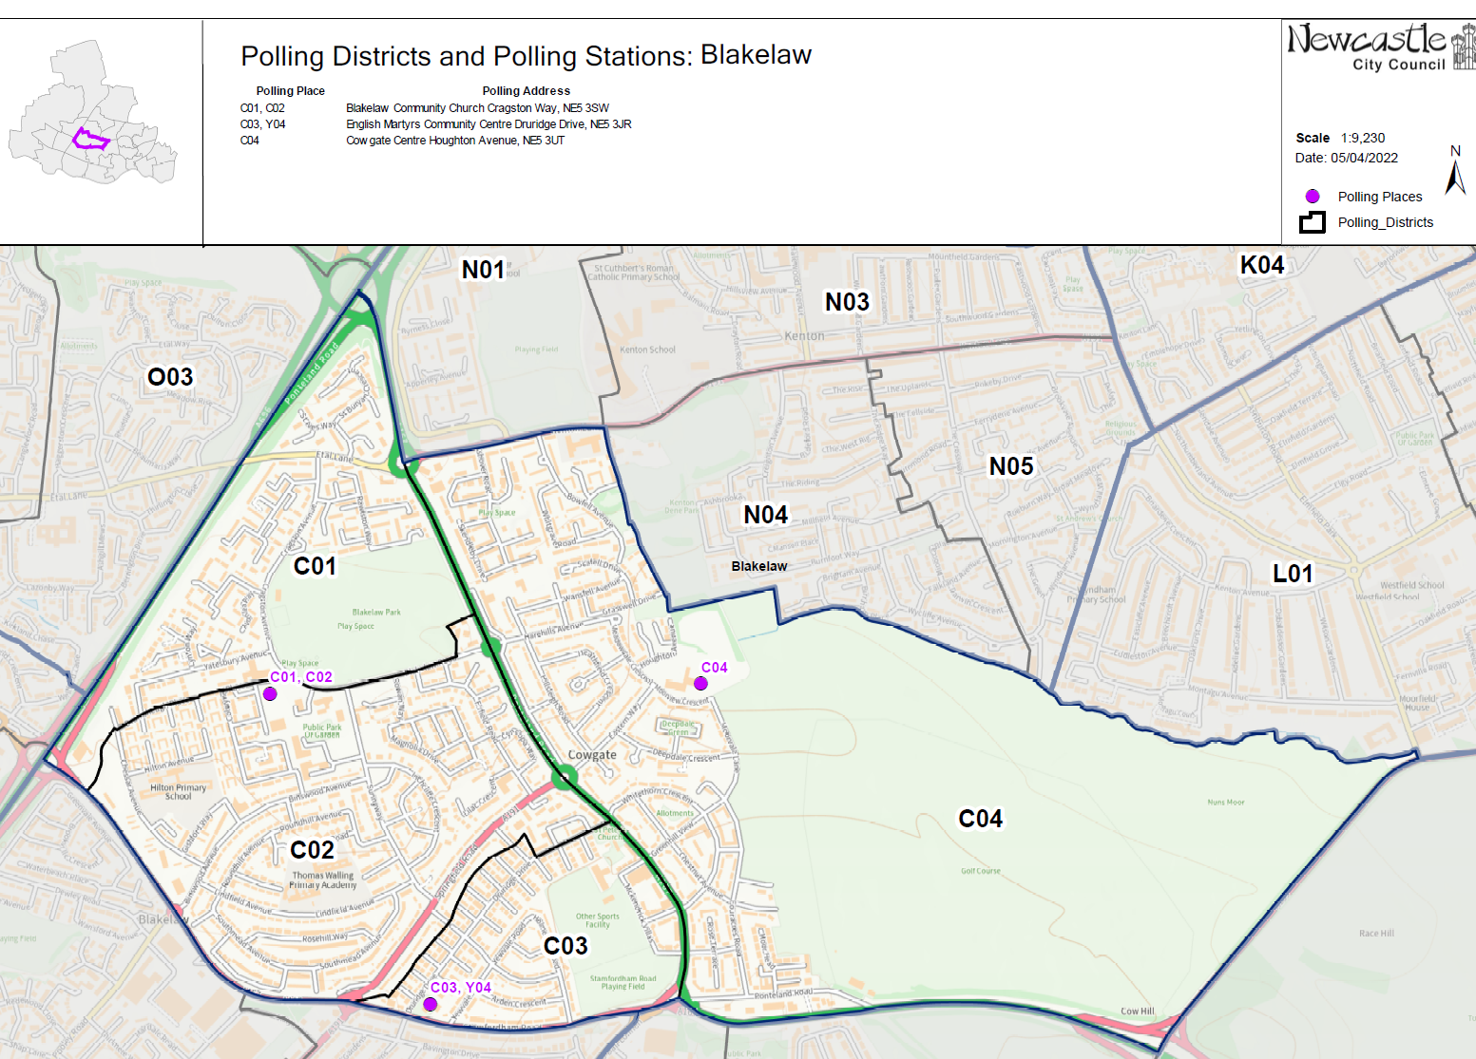

**(New)**

**Blakelaw and Cowgate Ward**

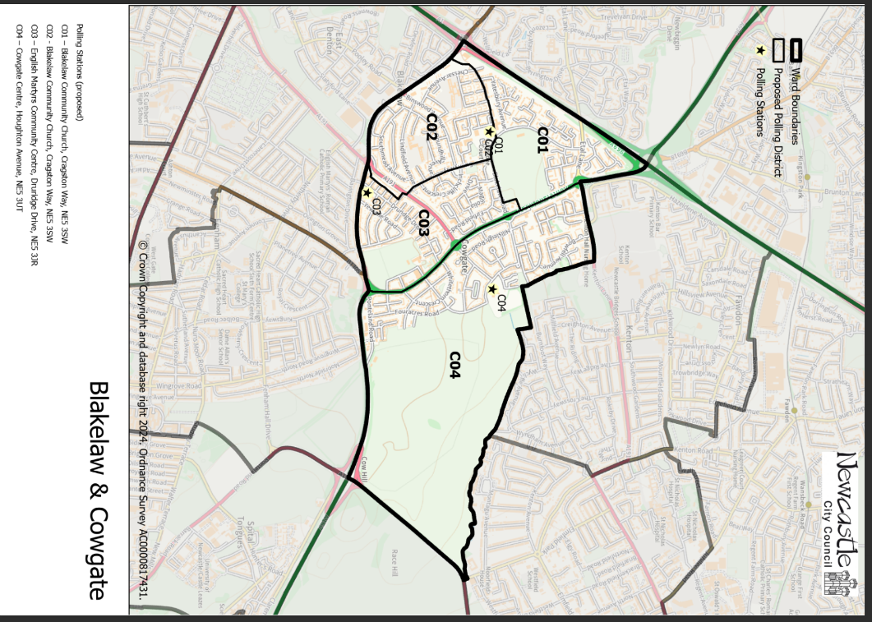This map shows the new ward and the proposed polling districts and the proposed polling places.

* **C01**

Blakelaw Community Church, Cragston Way, NE5 3SW

* **C02**

Blakelaw Community Church, Cragston Way, NE5 3SW

* **C03**

English Martyr’s Community Centre, Druridge Drive, NE5 3JR

* **C04**

Cowgate Centre, Houghton Avenue

NE5 3UT

**Blakelaw and Cowgate Ward**

**Polling District C01**

|  |  |  |
| --- | --- | --- |
| **Current Polling District** | **Current Polling Place** | |
| C01 (full) | Blakelaw Community Church, Cragston Way, NE5 3SW | |
|  | | |
| **Proposed Polling District** | **Predicted Polling Station**  **Electorate** | **Proposed Polling Place** |
| C01 | 716 | Blakelaw Community Church, Cragston Way, NE5 3SW |
|  | | |
| **Considerations and Proposals** | | |
| No change to the polling district boundary.    No change to the polling place.  Blakelaw Community Church is suggested as a double polling station to serve electors in the proposed C01 and C02 districts. | | |
|  | | |
| **Preliminary Consultation – Elected Members comments and feedback** | | |
| No comments received. | | |

|  |  |  |
| --- | --- | --- |
| **Current Polling District** | **Current Polling Place** | |
| C02* (part of) | Blakelaw Community Church, Cragston Way, NE5 3SW | |
|  | | |
| **Proposed Polling District** | **Predicted Polling Station**  **Electorate** | **Proposed Polling Place** |
| C02 | 1160 | Blakelaw Community Church, Cragston Way, NE5 3SW |
|  | | |
| **Considerations and Proposals** | | |
| Split current C02 to create proposed C02 and C03 districts. Properties to the west of Sunnyway would form part of the proposed C02 district. This is proposed to reduce elector numbers in each polling district.  No change to the polling place.  Blakelaw Community Church is suggested as a double polling station to serve electors in the proposed C01 and C02 districts. | | |
|  | | |
| **Preliminary Consultation – Elected Members comments and feedback** | | |
| No comments received. | | |

**Blakelaw and Cowgate Ward**

**Polling District C02**

**Blakelaw and Cowgate Ward**

**Polling District C03**

|  |  |  |
| --- | --- | --- |
| **Current Polling District** | **Current Polling Place** | |
| C02* (part of)  C03 (full) | Blakelaw Community Centre, Cragston Way, NE5 3SW  English Martyr’s Community Centre, Druridge Drive, NE5 3JR | |
|  | | |
| **Proposed Polling District** | **Predicted Polling Station**  **Electorate** | **Proposed Polling Place** |
| C03 | 1351 | English Martyr’s Community Centre, Druridge Drive, NE5 3JR |
|  | | |
| **Considerations and Proposals** | | |
| Split current C02 to create proposed C02 and C03 districts. The current C03 district remains unchanged, however takes on properties to the east of Sunnyway. This is proposed to reduce elector numbers in each polling district.  English Martyr’s Community Centre is suggested as a double polling station for the proposed C03 and Y04 districts. | | |
|  | | |
| **Preliminary Consultation – Elected Members comments and feedback** | | |
| No comments received. | | |

**Blakelaw and Cowgate Ward**

**Polling District C04**

|  |  |  |
| --- | --- | --- |
| **Current Polling District** | **Current Polling Place** | |
| C04 (full) | Cowgate Centre, Houghton Avenue, NE5 3UT | |
|  | | |
| **Proposed Polling District** | **Predicted Polling Station**  **Electorate** | **Proposed Polling Place** |
| C04 | 1602 | Cowgate Centre, Houghton Avenue, NE5 3UT |
|  | | |
| **Considerations and Proposals** | | |
| No change to the polling district boundary.    No change to the polling place. | | |
|  | | |
| **Preliminary Consultation – Elected Members comments and feedback** | | |
| No comments received. | | |

THIS PAGE IS INTENTIONALLY BLANK